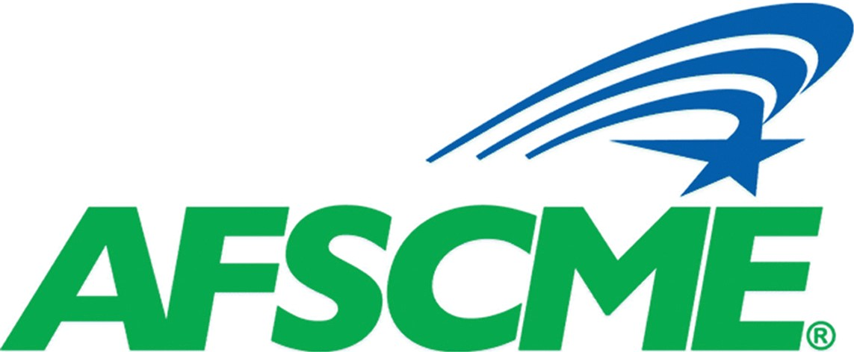

News

Local 3634
Local 3634

February, 2021

514 Shatto Place, Suite 215 - Los Angeles, CA 90020
Direct (213) 252-1395
Website: www.afscme-3634.org

Often times we take our jobs for granted and fail to realize the importance the Labor Department and other agencies play in our lives.
Labor Department helps to promote the development and welfare of the worker and insure that workers’ rights and benefits are protected.
Try hard to imagine a world without worker rights and benefits protected. Try to imagine a job without a collective bargaining agreement. Try to imagine a world without 40 guaranteed hours, lunch breaks, overtime or shifts to bid on.
Now stop to realize how fortunate we are to have a union that works hand in hand with the Labor Department to maintain our rights and privileges we enjoy today.
Please continue to support our union and make sure the union has updated information so you can be contacted.
Written by: Executive Board member, Melvin Stokes V.O. Supervisor

Newsletter
Greetings Sisters and Brothers:
The Local wanted to provide some information regarding the status of a few things. Our negotiation discussions to extend the current contract with MTA is ongoing. The MTA Board has approved for the company and the Unions to proceed in talks. We have a few meetings scheduled for this week and next and we will update you in real time on any progress. There have been questions regarding the Covid-19 vaccinations and if it is mandatory for Metro employees. It has been relayed to all Unions on the property by Executive Management that we are not required to do so and it is strictly voluntary.
CEO Phil Washington has communicated with several local and state officials within the past two months and requested to have transit workers elevated to a higher tier status as it relates to receiving the vaccination shots more quickly. We'll keep you posted on that request.
Although some restrictions have been lifted by the state recently due to declining Covid-19 numbers; we encourage you to still use good and sound judgement and continue to practice social distancing along with the wearing of your masks to protect yourselves and others. As always, we are thankful for your continued support of the Local.
Be Safe and Healthy!!!!
Respectfully and In Solidarity
AFSCME Local 3634 Executive Board
This is a friendly reminder:
February's
General Membership Meeting will be on the 27th at 10 am. Please RSVP by Wednesday February 24th.
Please provide and or update the Local with your contact information
Cell and personal email for our records which will allow us to contact and communicate with you in real time.

Confidentiality in the Workplace
To our members who have access to medical files, personal information and process employee paperwork/documentation during the course of your work day please use extra precaution in handling the information. Management has brought up a few matters to the Union regarding confidentiality.
Thanks for Your Cooperation

Prosperity, Peace and Good Health
Important information, please read

Please make sure to update your personal contact information including your alternate contacts with Metro. It is very important in times of emergencies that the employer may need to communicate immediately with you or your family for work and personal reason

